|  |  |
| --- | --- |
| Test Case ID | MS_003 |
| Test Description | To verify "Monthly Saver" modal is not displayed for search duration of greater than or equal to 28 days after user selects "Use my Current Dates". |
| Environment | Production |
| Status | Pass |
| Date Executed | 3rd July 2022 |
| Executed By | Aarthi Muthusami |
| Defect ID | NA |

**Pre-requisites**

1. User is in homepage <https://www.justpark.com/>

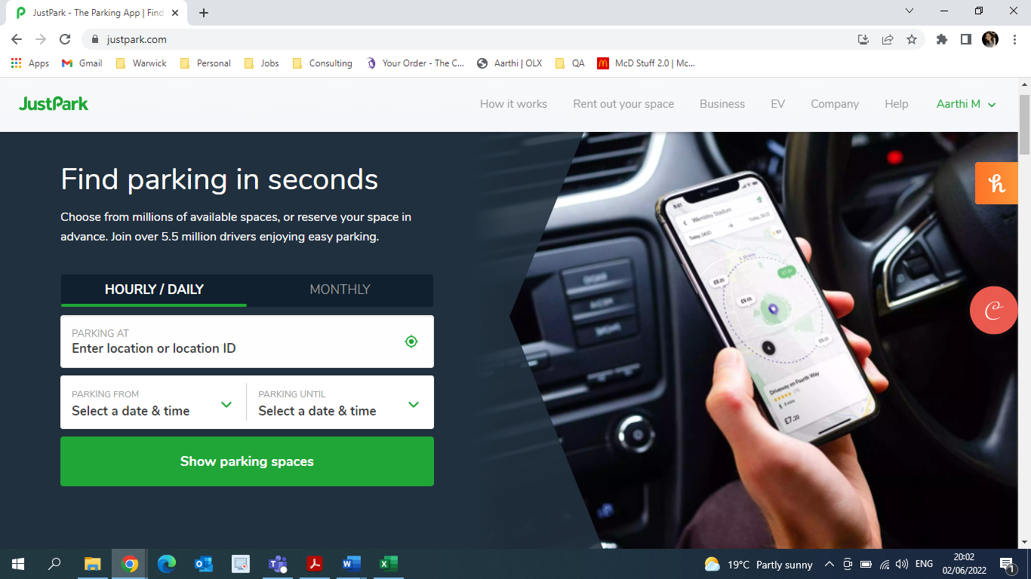

1. Search type is `Hourly/Daily`

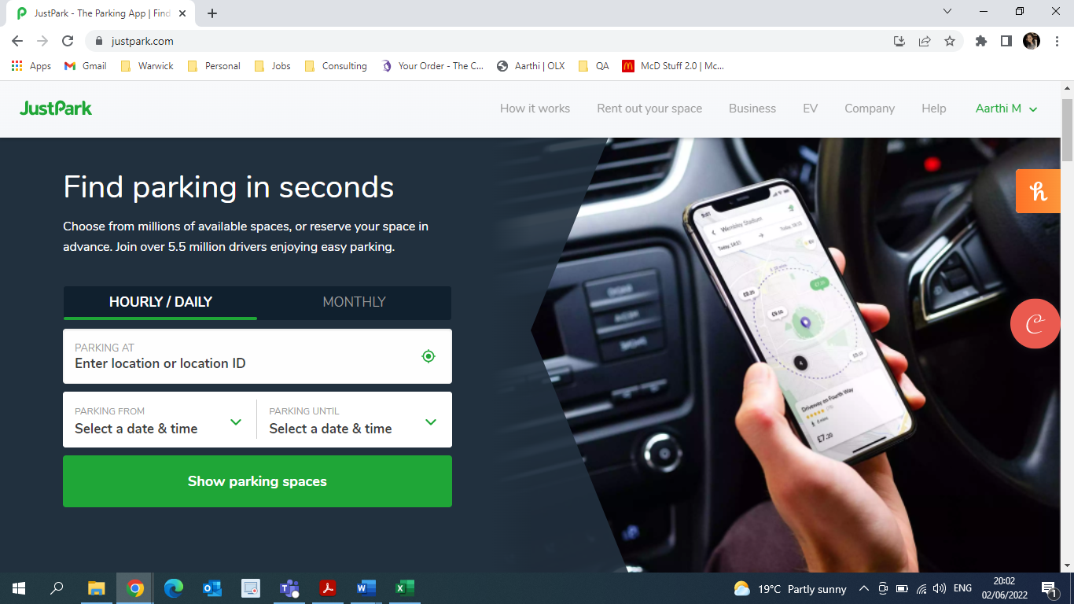

1. User performs search for less than 28 days

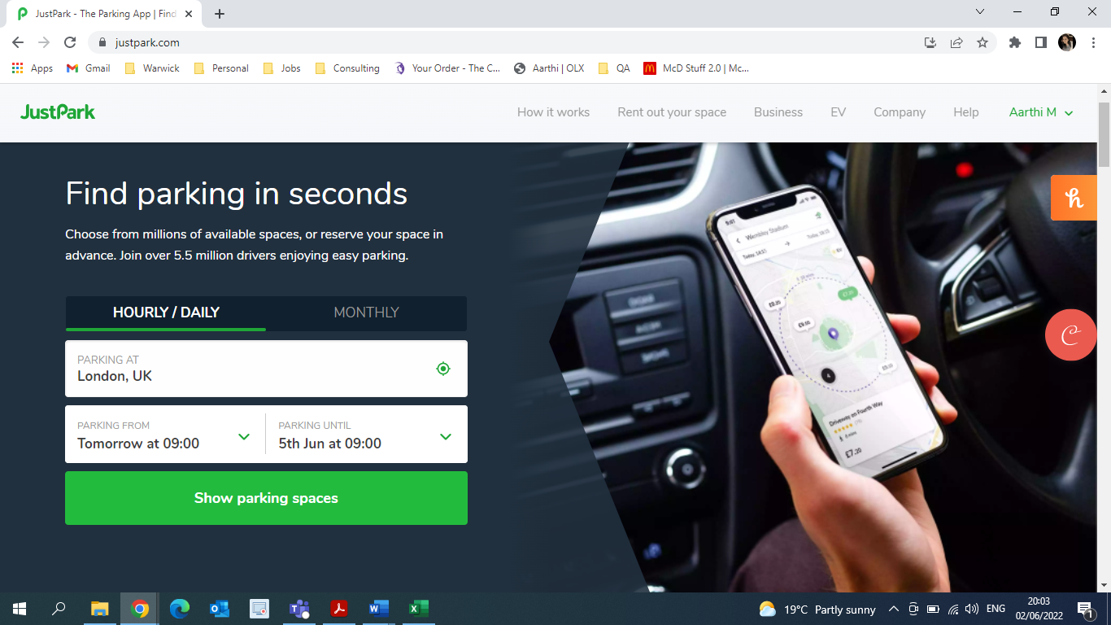

**Test Case Execution**

* Step 1: Ensure user is in Search Result Page - PASS
* Expected Result: User is in Search Result Page
* Actual Result: User is in Search Result Page

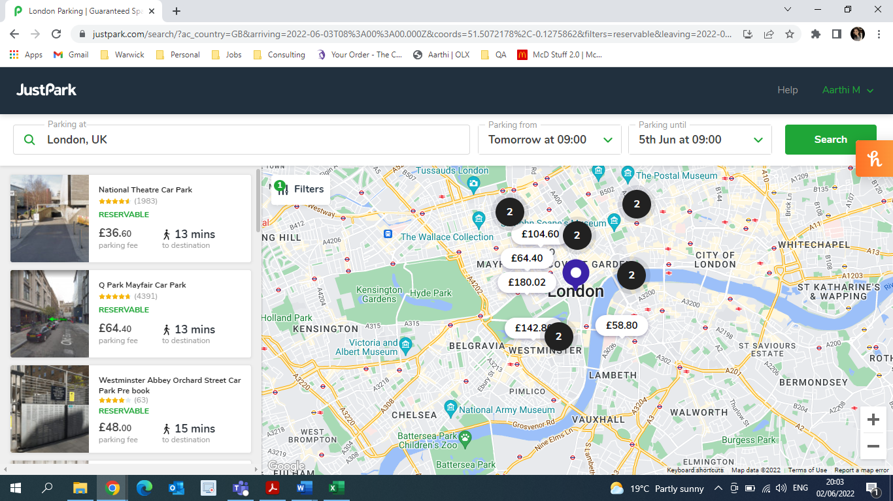

* Step 2: Ensure no "Monthly Saver" modal is not displayed - PASS
* Expected Result: Ensure no "Monthly Saver" modal is not displayed
* Actual Result: No "Monthly Saver" modal is not displayed



* Step 3: Change the parking end date and time to be greater than or equal to 28 days from start date and time - PASS
* Expected Result: Date is updated and is greater than or equal to 28 days from start date.
* Actual Result: Date is updated and is greater than or equal to 28 days from start date.

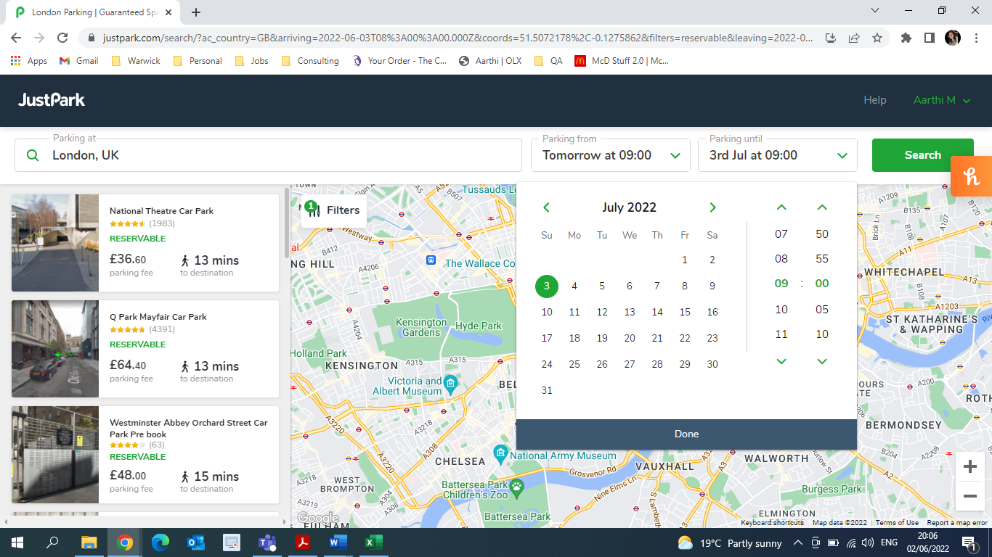

* Step 4: Click "Search" - PASS
* Expected Result: Search action is performed.
* Actual Result: Search is performed for given dates.

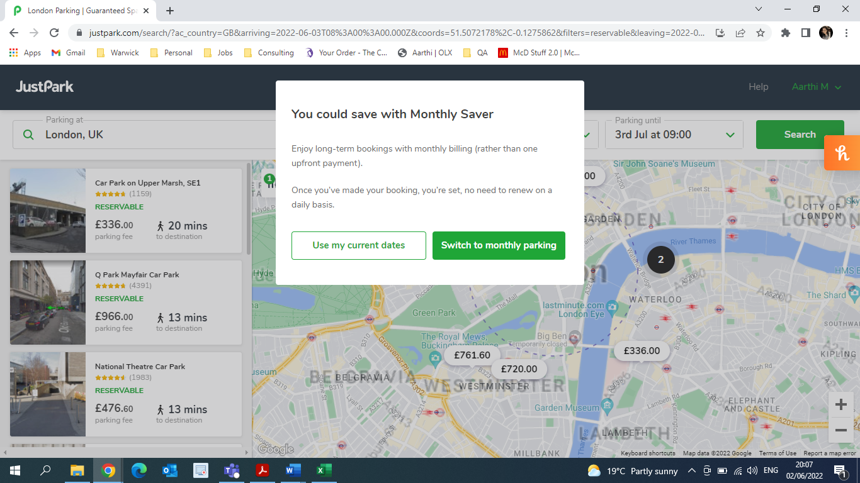

* Step 5: Ensure “Monthly Saver" modal is displayed - PASS
* Expected Result: "Monthly Saver" modal is displayed.
* Actual Result: "Monthly Saver" modal is displayed.



* Step 6: Click on "Use my current dates" - PASS
* Expected Result: "Monthly Saver" modal is closed.
* Actual Result: "Monthly Saver" modal is closed.

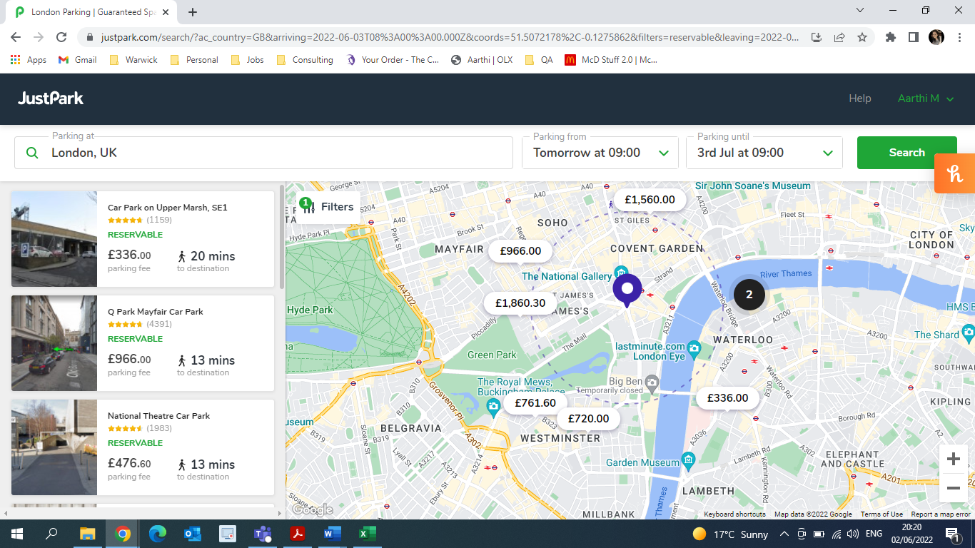

* Step 7: Verify that search dates are not altered - PASS
* Expected Result: Search dates remain the same.
* Actual Result Search dates remain the same.

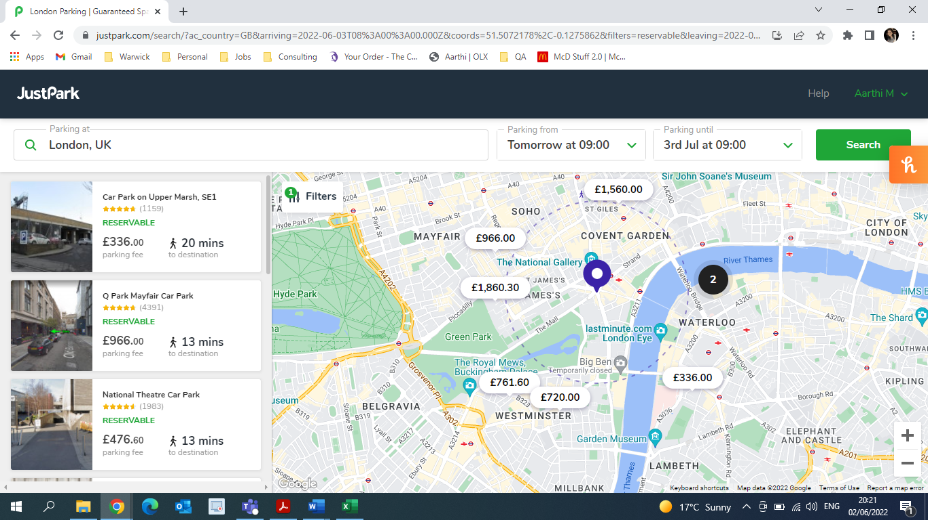

* Step 8: Perform another search greater than or equal to 28 days from start date and time - PASS
* Expected Result: Dates are updated and are greater than or equal to 28 days.
* Actual Result: Dates are updated and are greater than or equal to 28 days.

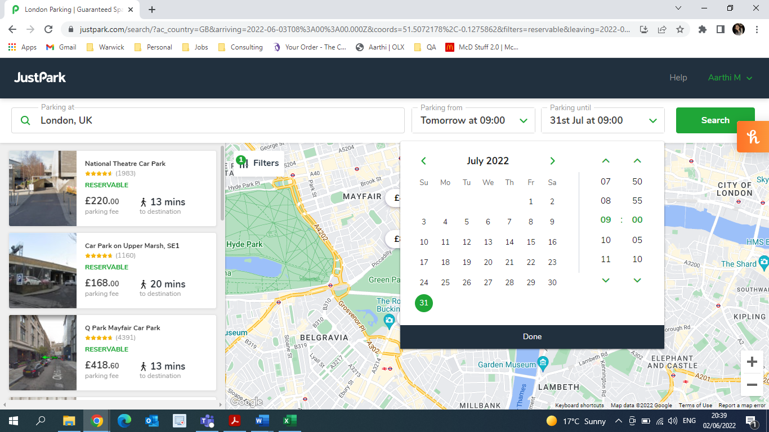

* Step 9: Click “Search” - PASS
* Expected Result: Search action is performed.
* Actual Result: Search action is performed.

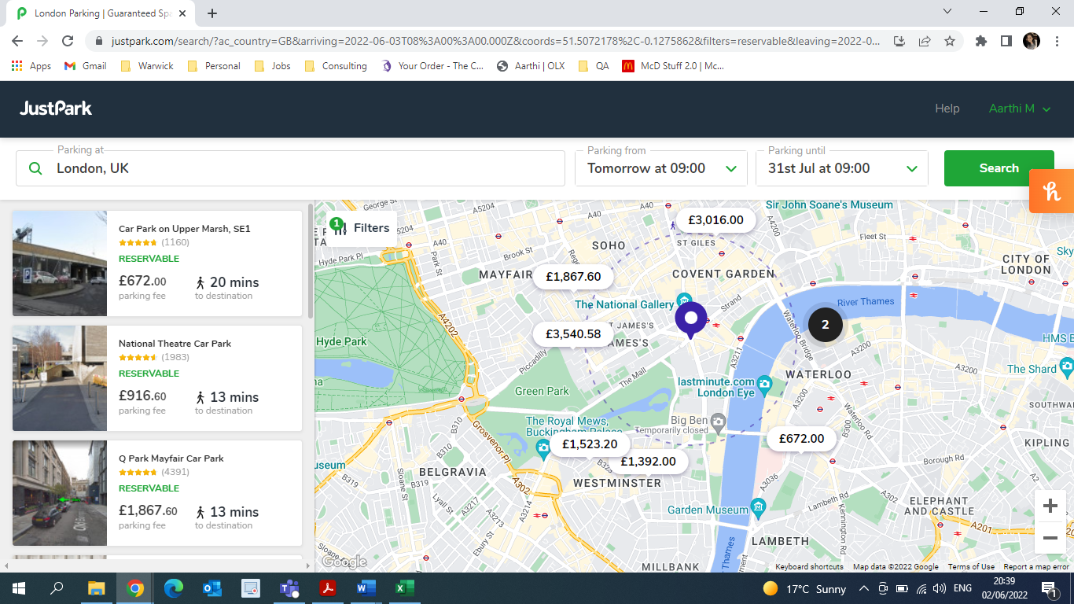

* Step 10: Verify “Monthly Saver" modal is not displayed- PASS
* Expected Result: "Monthly Saver" modal is not displayed.
* Actual Result: "Monthly Saver" modal is not displayed.

